School’s Vision for engaging families:

Through engaging and meaningful community events we will empower our stakeholders to collaborate with school staff to increase student achievement.

Identify partnerships that coordinate and integrate Title 1 and local/federal funds to provide opportunities that encourage and support parents in more fully participating in the education of their children and/or to help support learning at home.

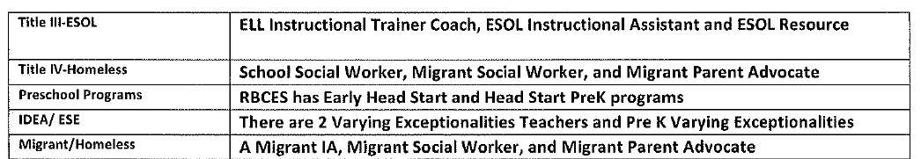

Utilize strategies to ensure meaningful communication.

Quarterly newsletters will be sent home to families and made available through all social media.

All students are provided a student planner and teachers use this as one consistent form of communication from home and school.

A school-home communication folder will be sent home weekly on Wednesday with any school-wide correspondence of upcoming events, academic progress, and other important information.

A call out system will be used to communicate upcoming events and other important information on a biweekly basis.

Teachers will communicate to parents on an ongoing basis on the progress of the students via phone, written correspondence, text, or email.

Provide an easily accessible resource area where parents and families can get information about the school facility , school policies, contacts, academic assistance, community resources and other materials.

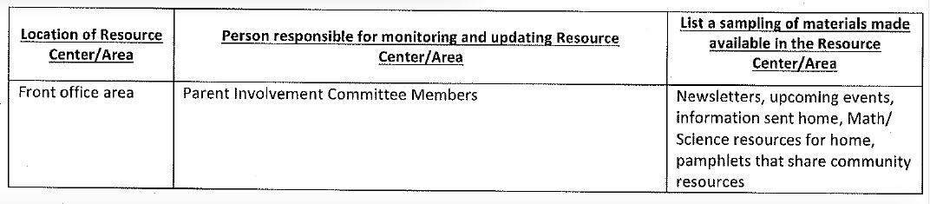

Date | Time | Event
August
8/7 | 5:00 – 7:00pm | Dual Language Classroom Open House
8/9 | ALL DAY | Registration Day/Meet The Teacher/ Title One Parent Compact distributed
8/23 | 5:00 – 8:00pm | McDonald’s Night
8/24 | 7:45 – 8:30am | SAC Meeting
8/28 | 6:00 – 7:00pm | Girl Scouts Information Meeting
September
9/11 | 9:00am OR 5:30pm | Dual Language Parent Training
Varied by GL | 4:00-7:30pm | Parent Conference Night
9/18 | 6:00 – 7:30pm | Open House- Title One Annual Meeting
9/20 | 6:30 – 7:30pm | Cub Scouts meeting
9/21 | 7:45 – 8:30am | SAC Meeting
9/24 | 8:45 – 9:15am | Wild Cat Roar (Student Recognition)
9/28 | 4:00 – 7:00pm | FALL FESTIVAL Fund Raiser
October
10/9 | 9:00am OR 5:30pm | Dual Language Parent Training
10/18 | 5:00 – 8:00pm | McDonald’s Night
10/19 | 7:45 – 8:30am | SAC Meeting
10/29 | 8:45 – 9:15am | Wild Cat Roar (Student Recognition)
10/23 | 6:00 – 7:00pm | Hispanic Heritage Showcase
November
11/9 | 9:00 – 9:20am | Veteran’s Day: Flag Pole Friday
11/14 | ALL DAY | Great American Teach-In
11/16 | 7:45 – 8:30am | SAC Meeting
11/26 | 8:45 – 9:15am | Wild Cat Roar (Student Recognition)
11/27 | 5:30 – 6:30 | DL Parent Training
December
12/7 | 6:00 – 9:00pm | Dade City Parade
12/11 | 6:00 – 7:00pm | Dual Language Family Celebration Event (Potluck)
12/13 | 5:00 – 8:00pm | McDonald’s Night
12/14 | 7:45 – 8:30am | SAC Meeting
12/17 | 8:45 – 9:15am | Wild Cat Roar (Student Recognition)
12/19 | See event flyer | Holiday Parent Event (Photo opportunity and activities)
Date | Time | Event
January
1/8 | 5:00 - 7:00 PM | K/1 Parent Training
1/25 | 7:45 – 8:30am | SAC Meeting
1/28 | 8:45 – 9:15am | Wild Cat Roar (Student Recognition)
February
2/5 | 9:00am OR 5:30pm | K/1 Parent Training
2/15 | 6:00 – 8:00pm | Valentine’s Day Family Dance
2/15 | 7:45 – 8:30am | SAC Meeting- Parent Group Survey
2/21 | 5:00 - 8:00pm | McDonald’s Night
2/25 | 8:45 – 9:15am | Wild Cat Roar (Student Recognition)
2/27 | 6:00 – 7:00pm | FSA Parent information night
March
3/5 | 9:00am OR 5:30pm | K/1 Parent Training
3/14 | 10:00 – 2:00pm | Field Day
3/15 | 7:45 – 8:30am | SAC Meeting- Parent and Family Engagement/Title One feedback
3/29 | 8:45 – 9:15am | Wild Cat Roar (Student Recognition)
April
4/2 | 5:00-7:00 pm | K/1 Parent Training
4/12 | 7:45 – 8:30am | SAC Meeting
4/18 | 5:00 - 8:00pm | McDonald’s Night
4/29 | 8:45 – 9:45am | Wild Cat Roar (Student Recognition) & FSA Pep Rally K-5
May
5/6 | All Day | Kindergarten Registration
5/6-5/10 | All Day | Staff Appreciation Week
5/14 | 5:00 - 7:00 pm | Dual Language EOY Celebration
5/16 | 5:00 – 8:00pm | McDonald’s Night
5/17 | 7:45 – 8:30am | SAC Meeting
5/20 | 8:45 – 9:15am | Wild Cat Roar (Student Recognition)
5/24 | 10:00 – 11:00am | 5th Grade Moving Up Luncheon Celebration
5/29 | All Day | Dual Language Portfolio Review

