Installing Zoom on Mac Computers

Most student desktops contain the Zoom icon. This does NOT mean that Zoom is loaded on their computer. To effectively run Zoom, please follow these instructions..

1. Once logged in, locate the self-service icon at the bottom of the desktop, click to open
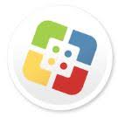
Self-service icon

2. Once the self-service opens, on the top right, there is a search bar. Type
in Zoom.
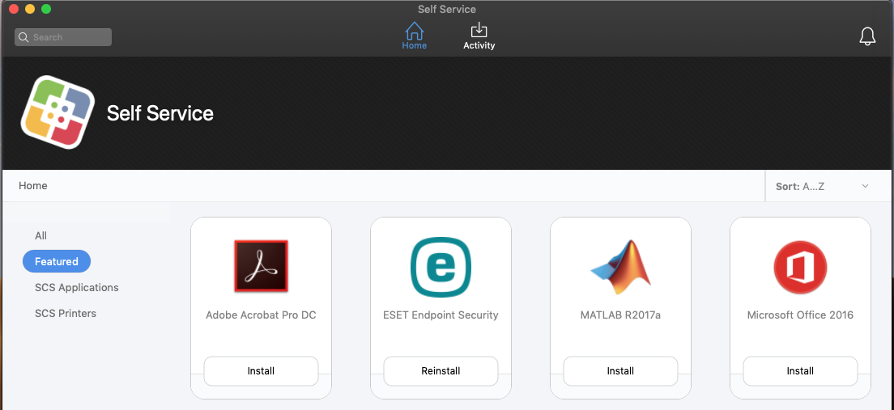
Search bar,
type Zoom here
and click enter

3. The Zoom Icon will appear. Once Zoom appears, click it, which will prompt the install
Zoom. The final step is to click install.

Click install

Once installed, restart the computer. Zoom will now be loaded on the computer desktop. Students can join a meeting from there with the meeting number and password or through a emailed link.

