Goals & Requirements
Parent involvement in each child’s education is of great importance in ensuring a child’s success in school.

As a Title I school, Rodney B. Cox is committed to the involvement of families. Families are encouraged to participate in the view and implementation of the Parent and Family Engagement Plan. Goals of the plan include:

- Coordination and integration of family involvement programs
- Annual meeting each Fall designed to inform families of the Title I program
- Flexibly scheduled parent meetings
- Implementation of activities that build strong family involvement
- Establishment of a school-home compact to promote the connection between home and school
- Encouraging on-going and open communication through a variety of formats
- Language translators to assist families as needed
- Staff training focused on communicating with parents

The plan encourages and supports full participation of parents in their child’s education. Parent input will help guide the development of our School Improvement Plan, Title I program, Family Involvement Plan, and Family/School Compact. The SAC will review and update the plan annually.
School Resources

RBCES staff available to assist families:
- Parent/Volunteer Coordinator
- Parent Resource Room
- School Secretary
- Data Entry Secretary
- School Nurse
- Clinic Assistant
- School Counselor
- ESOL Instructional Assistant
- Social Worker
- School Psychologist
- Principal & Assistant Principal
- Cafeteria Staff
- STAR PLACE Program
- Art, Music, and PE Teachers
- Plant Manager

Family Resources
- Dental Clinic
- Flu Shots
- Vision Van
- Summer Breakfast/ Lunch Program
- Immigrant supports

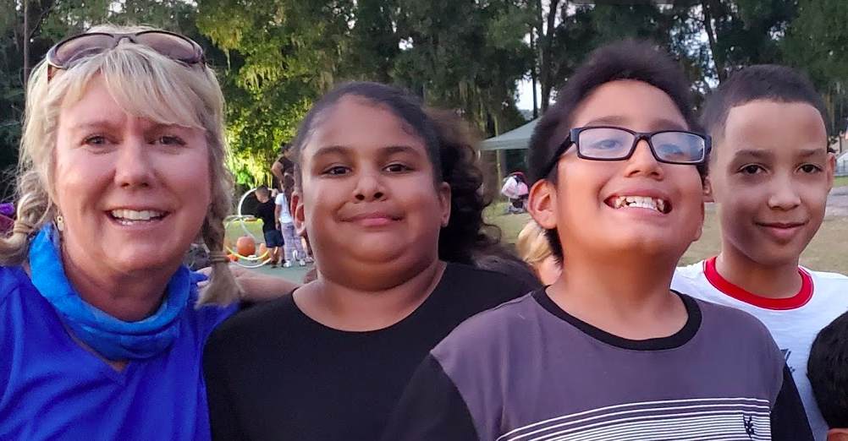

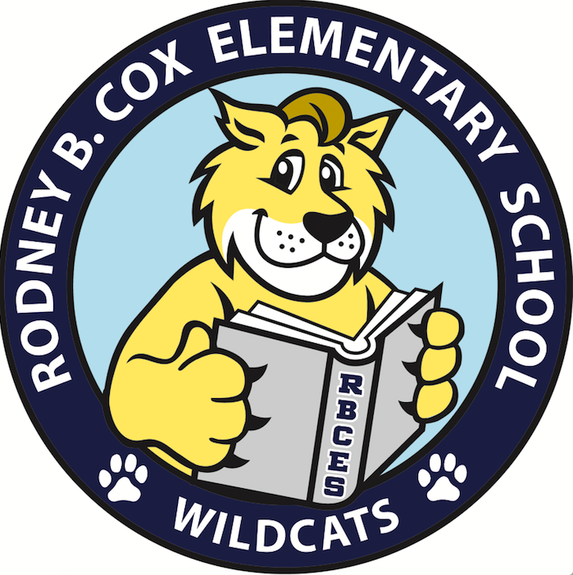

Family Involvement

Our Core Value Statement
Our mission is to share responsibility with all stakeholders to provide high-quality instruction for all learners to ensure that each student will thrive emotionally, academically, socially, and physically in a safe environment.

37615 Martin Luther King Blvd.
Dade City, FL 33523
Phone: (352) 524-5100

Here are some opportunities for families to provide input into RBCES family improvement plan:

- Join SAC
- Communicate regularly with your child’s teacher
- Sign the school/home compact
- Participate in school functions and activities
- Become a volunteer, register annually at: www.rbces.pasco.k12.fl.us

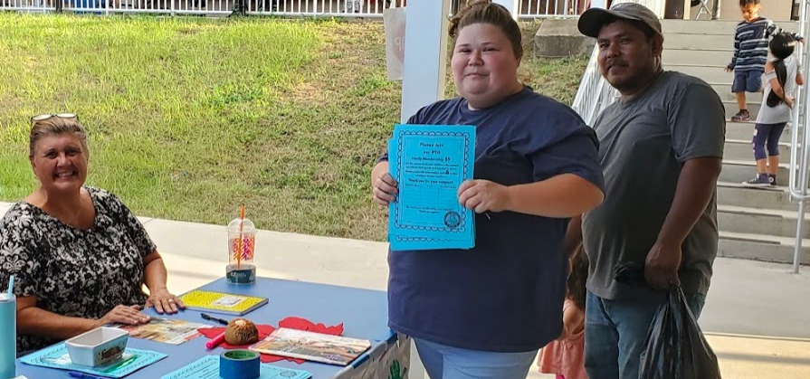

Communication

Ongoing and reciprocal communication between home and school is vital to ensure the success of your child.

Ways to stay connected:
- Parent/teacher conferences
- Use student planners/ communication folder for open dialogue
- School-wide information comes home every Wednesday
- Visit school webpage for upcoming events and student activities
- Connect Ed for recorded phone messages
- Remind communication app
- Event Feedback Forms
- Written notes and email
- Like us on Facebook: @RBCESWildcats
- Follow us on twitter @RBCESPrincipal

Activities

What can families and their children do with the school?
- Kindergarten Registration
- Meet the Teacher/Orientation Day
- Open House
- Title I meetings
- Math & Science Night/ STEM
- Winter and Spring Concerts
- Cookies & Milk with Santa
- Muffins with Mom
- Donuts with Dad
- Book Fair
- Parent/Teacher Conferences
- SAC Meetings
- FSA Prep Meetings
- Field Trips
- Classroom Visits
- IRLA Night
- National School Lunch and Breakfast Week
- Great American Teach In
- School Performances

